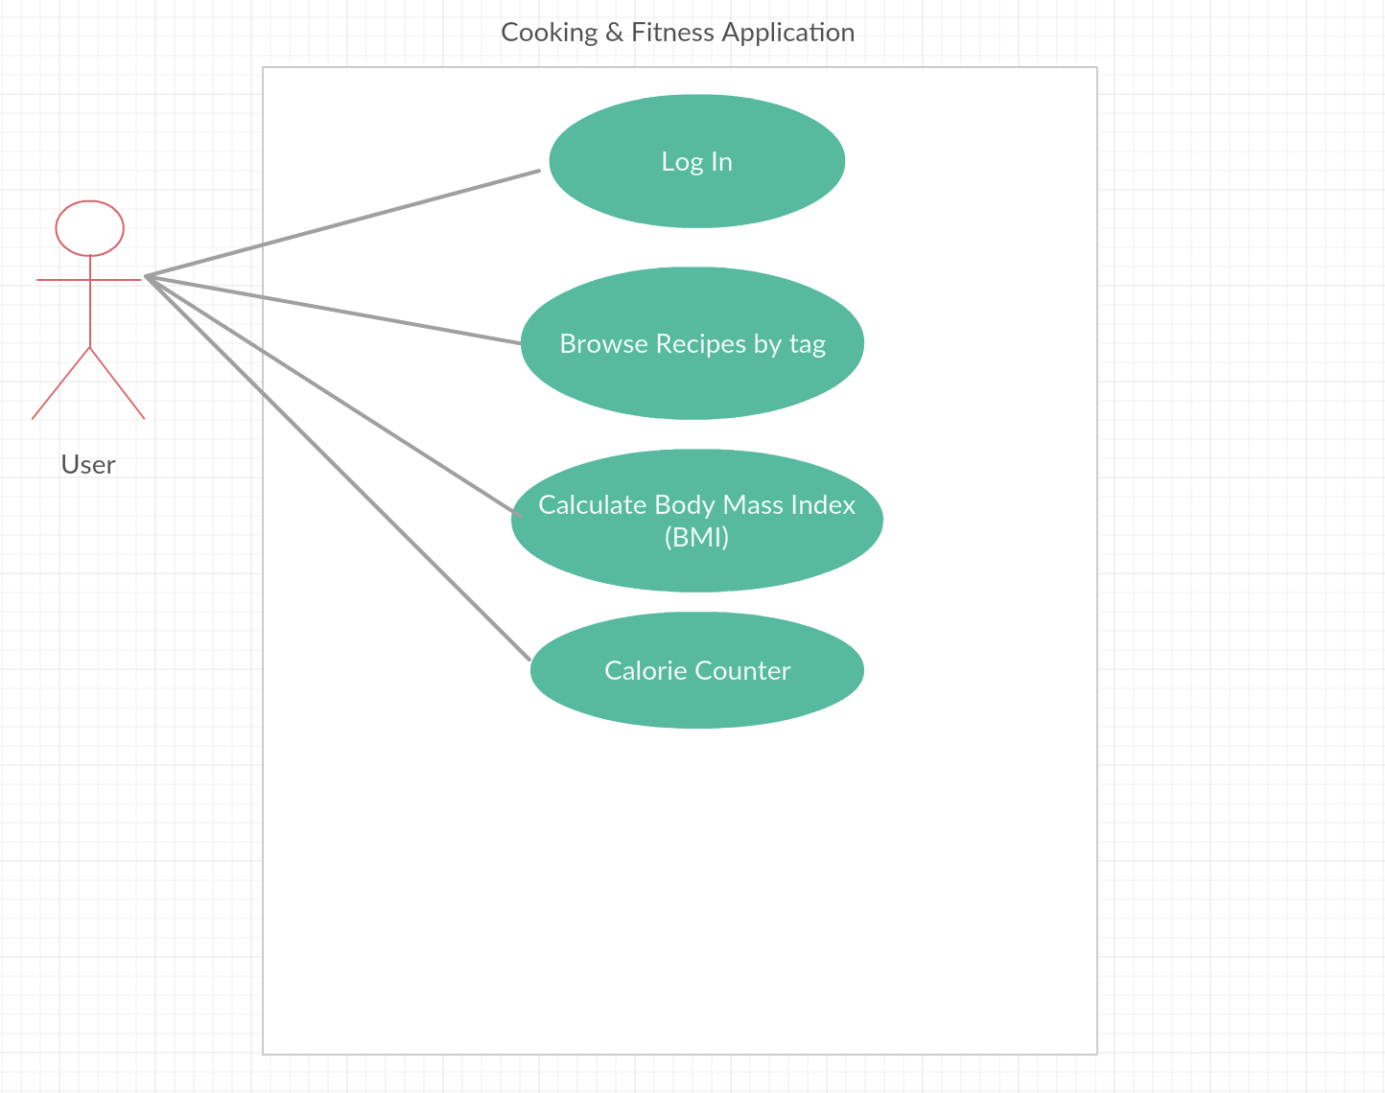

|  |
| --- |
| Use Case Title: Innovative cooking and fitness application |
| Primary Actor: User |
| Stakeholders: Users prepared to share their experience, Experienced end users, Inexperienced end users, Application maintenance staff, System analyst, Application developers. |
| Precondition: User login into their desired account to access recipes and keep track of their fitness. |
| Minimal Guarantee: The amount of ingredients of the preset recipes were listed incorrectly. |
| Success Guarantees: The application displays all necessary items to make the selected recipe |
| Trigger: User access the application homepage |
| Main Success Scenario:   1. User searches for an array of dishes. 2. The users application displays all items categorized by food type; ex: different cultural backgrounds. 3. The users application displays all possible recipes based on the selected item. 4. The user selects one recipe from the displayed list by from the application. 5. The users application displays all necessary items to make the selected recipe. |
| Extensions:  1a. The application’s search engine or function is not available.  1a1. User quits the application and goes looking for another cooking and fitness application  2a. The application doesn’t display the recipes in which user is looking for.  2a1. User quits the application  3a. The application doesn’t display all the recipes based on the selected item.  3.a.1 Application crashes. User starts again.  3.a.2 Application crashes. User quits.  4a. The users selected recipe crashes  4.a.1 User quits  5a. The application doesn’t display the necessary items to make the selected recipe.  5.a.1 Application crashes. User starts again  5.a.2 Application crashes. User quits. |